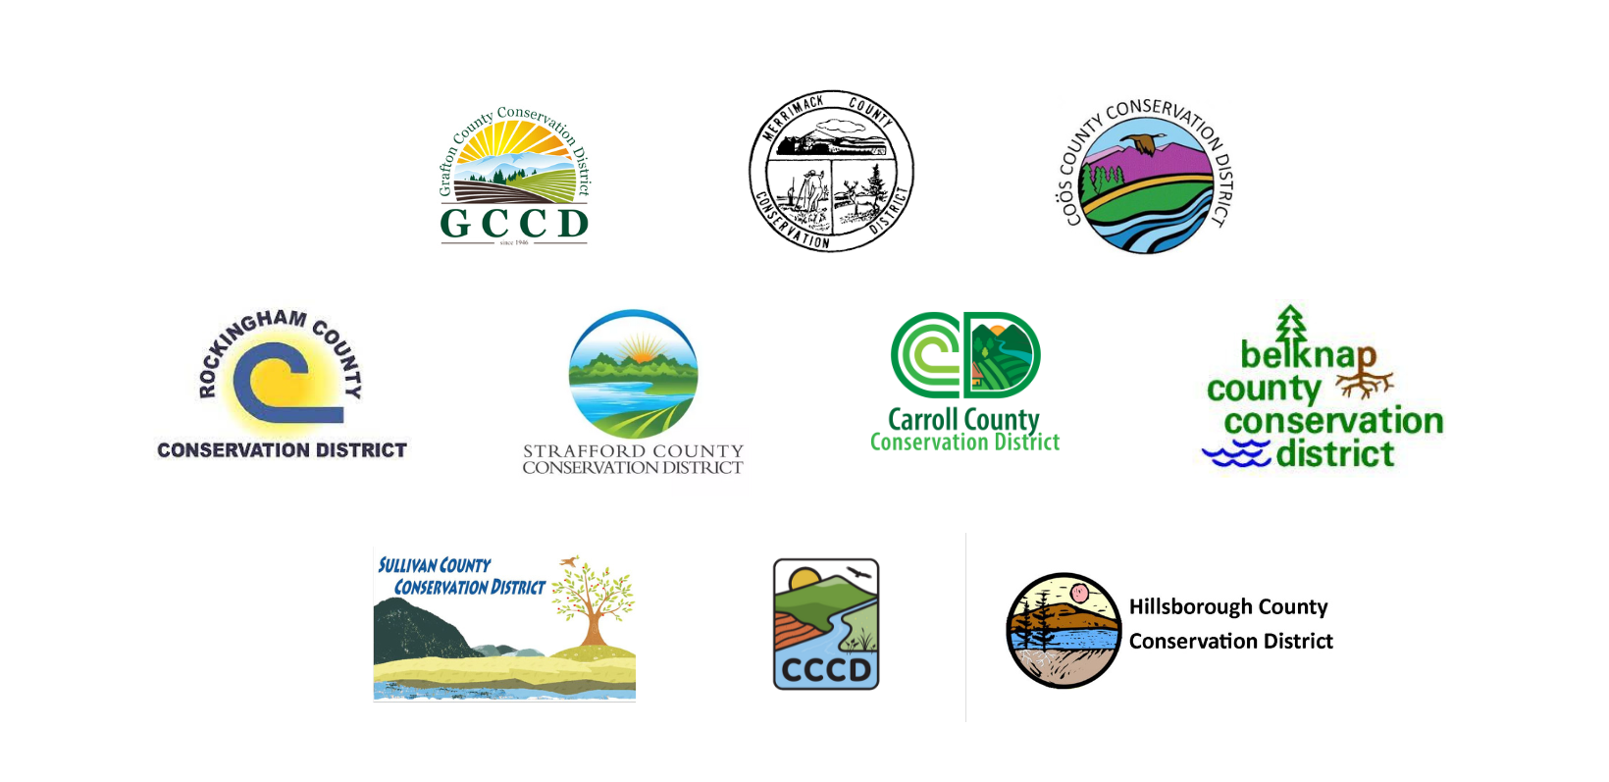
NH Conservation Districts Climate Resilience Grant

I. Introduction
The NH County Conservation Districts have launched this farm viability program to improve the resilience of NH farms in the face of extreme weather events and a changing climate. Direct grants to farms to invest in on-farm infrastructure, equipment, and innovative practices will support farm profitability and the long-term viability for NH’s agricultural sector.

The mission of the NH Conservation Districts Climate Resilience Grant is to support and empower local farmers to build climate resilience throughout the granite state. This will be done through reducing the impact of agriculture on climate change (mitigation) through greenhouse gas emissions reduction and carbon sequestration, and through increasing the resiliency of New Hampshire Farms in a changing climate (adaptation), while meeting farm’s conservation goals and needs. Extreme weather events, frequent and prolonged droughts, and increased pest pressures are increasing challenges for NH farms. This grant through the NH County Conservation Districts seeks to support farmers in meeting those challenges.

This grant program was designed with a high level of farmer input to ensure the most pressing needs of farms will be met. The NH Conservation Districts have also worked in close partnership with the USDA Natural Resources Conservation Service and other conservation partners to ensure that this statewide program fills the gaps that are not being adequately met by federal funds. Funds are available for projects that mitigate the impact of agriculture on climate change and enhance the on-farm adaptations to projected climate conditions. Preference will be given to projects that can demonstrate strong potential in mitigation and adaptation.

Learn more about the risks of climate change in NH, here:
- https://statesatrisk.org/new-hampshire/all
- https://19january2017snapshot.epa.gov/sites/production/files/2016-09/documents/climate-change-nh.pdf
- https://www.nhpr.org/nh-news/2021-08-12/un-climate-change-report-new-hampshire
- https://interactive-atlas.ipcc.ch/

II. Eligible Projects
The NH County Conservation Districts request proposals from farms who seek funding to make investments in the following areas, but welcome proposals for projects that are not represented on the list below if they are aligned with the mission and goals of the program:

- Practices which promote minimizing soil erosion and maximizing carbon capture:
  - Cover Cropping
  - Transitioning to reduced/no-tillage
  - Mulching
  - Wind breaks/buffers
  - Equipment and materials to promote healthy soil practices (ex. Silage tarps,, roller/crimper, low or no-till implements).
  - Transitioning to rotational grazing and grass based systems (fencing)
  - Crop rotation
  - Fixing gullies on fields, stopping further soil loss
  - Soil nutrient management
  - Soil testing
  - Soil carbon monitoring and testing
  - Soil sensors

- Practices which promote sustainable water management:
  - Waste/Manure storage and management
  - Run-off capture and re-use
  - Riparian pollinator buffers and plantings
  - Efficient irrigation systems
  - Efficient Well systems
  - Water sensors

- Practices which increase energy efficiency and renewable energy use:
  - Solar installation and/or batteries
  - Energy efficient equipment
  - LED lights
  - Climate batteries

- Integrated Pest Management Practices (IPM)
  - Fruit and Vegetable Netting
  - Weather stations and sensors

The following will be funded:
● Practice implementation costs
● Materials costs
● Architectural, land planning, and/or engineering services
● Other direct expenses
● Equipment (All equipment purchased through grant funds must be new and
under product warranty or, in the case where this is not possible, the equipment must have a lifespan that justifies the investment)
● Technical assistance
● Consultant and legal services

The following will not be funded:
● Advertising
● Research and feasibility studies
● Efforts that will not lead to increased climate resiliency through adaptation
and/or mitigation
● Experimental projects

Priority will be given to projects/practices that:
● Focus on climate change mitigation or adaptation
● Follow application guidelines
● Have a detailed plan for project implementation, education, long-term
maintenance, and sustainability
- Have a realistic and well-researched budget
● Are scientifically supported by NRCS, UNH Extension, and NHACD
● Have a strong track record of success
- Have an identified technical advisor as a partner on the project
● Provide opportunities to partner with their local conservation district to offer
community education, and share their project story or testimonial through
conservation district publications and/or social media
● Provide opportunities to partner with their local conservation district, NHACD,
and partner organizations to monitor their projects, and assess project implementation and results for future programming and research.

III. Eligible Applicants & Sites
A. Eligible Applicants
Farms in New Hampshire. Eligible farms must be selling direct to consumer, or through wholesale markets for at least two years. Eligible farms must have secure access (own, lease) to land on which the operator is farming. If leasing, the lease must be in writing, and have a term long enough for the farmer to complete the proposed improvement project and see a return on the investment. To receive funding a farm must operate in compliance with all applicable federal, state, and local regulations.

B. Eligible Sites
Projects will need the signed consent and approval of the appropriate governing body or landowner(s).

IV. Program Funding and Project Duration

A. Funding Availability
The grant will provide a cost share program for farms – grant covers up to 75% of project costs not to exceed $10,000/farm. Farmers are responsible for covering 25% of project costs.
Please note that the grant consists of two different funding pools: one for regenerative and ecological practices (e.g. soil health, water efficiency, integrated pest management) and one for renewable energy and energy efficiency projects. Each pool has limited funds and will be competitive.
Program administrators reserve the right to offer funding to selected projects at an amount less than requested in the application budget. Program administers also reserve the right to deny funding to applicants that do not propose a strong project. Remaining funding, if any, will be made available in future grant rounds.

Program participants must provide receipts verifying expenditures have occurred within the contract period. Relevant costs incurred prior to contract execution can be funded on a case-by-case basis, and require a waiver, reasonable explanation, and approval from Conservation District staff for reimbursement. Contact your District’s staff for more information.

B. Project Timeframe
Project must be completed and final report submitted by December 31, 2025

C. Timeframe: Grant Award Funding Decisions and Allocations

Process | Approximate Time Frame
1. RFP is available. | November 1, 2023
2. Optional Informational Session & one-on-one Conservation District Assistance available | December 7, 2023
2. Proposals are due. | February 1, 2024
3. Proposal review process. Applicants may be contacted for additional information to clarify the project. | February 1-March 31, 2024
4. All Applicants are notified of funding decision. | By March 31, 2024
5. Project ends and report and photos are due. | December 31, 2025

o No payment will be made for project costs incurred prior to notification of grant award.

V. Application Submittal Procedure
The proposal can be submitted digitally (preferred) or by hard copy in the mail to County Conservation District staff. Applications must be postmarked by the due date.

A. Proposals Mailed to:
Interested applicants can contact their Conservation District for more information on how to submit their printed or electronic application: https://cdeanh.org/contact-us/

Proposal Due Date: February 1, 2024

VI. Grant Funding and Information Required for Funded Applications

A. Successful Applicants – Grantees - will be required to submit the following additional information upon notification of award:

1. Signed contract provided by your NH County Conservation District.

2. Signed W-9 Form (Please note that grant funds are taxable income and a 1099 form will be provided to farms by the Conservation District in following year)

3. Contracts of subcontractors if applicable. Subcontractors must be reputable and insured.
4. Certificate of Liability Insurance listing your County Conservation District as additional insured.

VI. Project Monitoring

A. 50% of payment for the project will be made upfront, with the remaining 50% made upon the completion of the project and submission of the final report.

B. Grantees are required to submit a final project report in a digital format. A template will be provided. The final project report shall document the completion of project tasks and the results attained, include documentation of all expenses including an In-Kind Contribution Form (provided by your District), contain before and after photos, as jpg files, of the project as applicable, photo of your project taken with Climate Resilience Grant banner provided by your district (optional), and share a testimonial from the farm owner and/or manager on the benefits the financial assistance from the climate grant fund provided.

VII. Project Insight, Implementation, and Technical Assistance Advisors

A. The NH Conservation Districts have created this program with a high level of input from community partners and technical assistance providers. The NH Conservation Districts encourage interested applicants and awardees to work with technical assistance providers in determining best projects to meet farm needs and climate adaptation and/or mitigation goals. The NH Conservation Districts also encourage awardees to consult with technical assistance providers to ensure sustainable implementation of awarded projects. Please note in your application if you have consulted a technical assistance provider, in what capacity, and which technical assistance provider you are working with. Your application will rank higher if you are working with a technical assistance provider on this project and they submit a Partnership Form for you to turn in as part of your application. Partnership Forms can be found on Conservation District Websites.

B. Technical Assistance Providers include, but are not limited to, the following:
- USDA Natural Resources Conservation Service (NRCS), https://www.nrcs.usda.gov/conservation-basics/conservation-by-state/new-hampshire
- UNH Cooperative Extension: https://extension.unh.edu/
- NH Association of Conservation Districts (NHACD) Conservation Planners, contact:
  - https://www.nhacd.net/
- Private Sector Crop Advisors
- National Center for Appropriate Technology (NCAT): https://www.ncat.org/agriculture/
- Lakes Region Community College NH Rural Renewables Technical Assistance Program: https://www.lrcc.edu/programs-training/nh-rural-renewables/, Contact Andy Duncan: aduncan@ccsnh.edu

