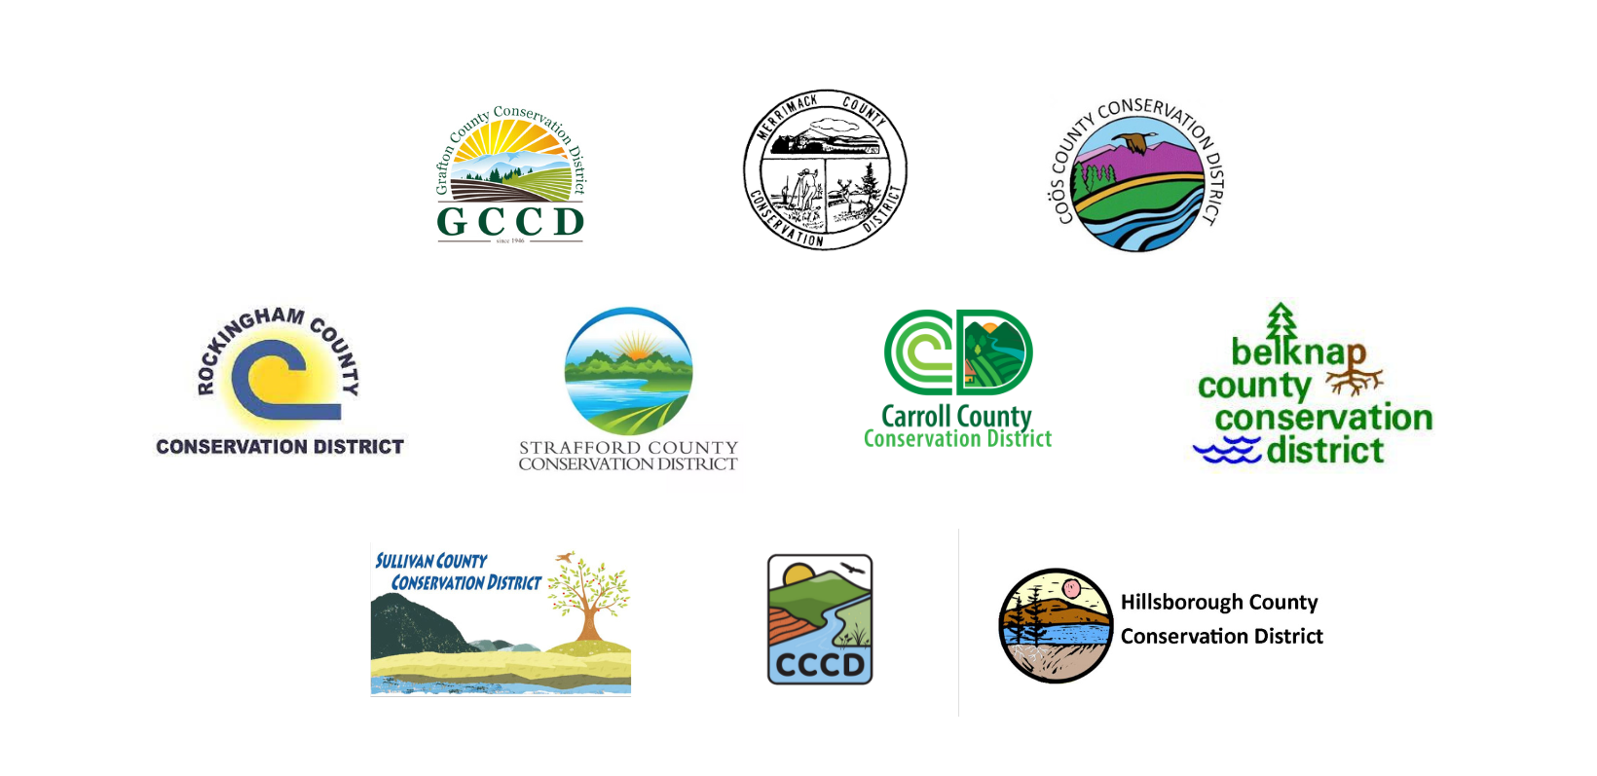
2024 NH Conservation Districts Climate Resilience Grant Application

Project Title: Amount Requested:

Total Budget: Project Location:

Applicant Information

Applicant Name (First and Last): Applicant Farm:

Email: Phone Number:

Are you a limited resource farmer, beginning farmer, socially disadvantaged farm, and/or veteran farmer as defined by the USDA (view definitions here). If yes, please indicate below which USDA categories are applicable to you?

Farm Location (Street Address, Town, State, and County):

Year Your Business Started:

Briefly Describe Your Product(s) or Service(s):

How Did You Hear About this Opportunity?:

Farms are encouraged to work with an Agricultural Service Provider (e.g. UNH Cooperative Extension Educator, Crop Advisor, USDA NRCS Conservation Planner, NHACD Planner, etc,) as a Technical Advisor on project planning and implementation. If you are working with an Ag Service Provider for technical assistance on your project please have them complete a Partnership Form and submit it with your application.

If you are not working with an Ag Service Provider please share your plan on how you will effectively complete your proposed project. Please outline the expertise and experience needed and who you will be working with to provide it.

If you are not working with a service provider and would like to please contact your County Conservation District for a referral and have them connect you.

Project Description
(Please answer the following questions (#1-10) in 1,000-2,500 words total in this question format. Please include as much detail as possible. Please do not use a separate narrative.)

- Please describe your project?

- What are the project’s goals?

- What are the tasks and timeline of the project?

- How will this project improve your farm’s ability to mitigate or adapt to climate change?

- How will this project benefit your farm?

- Please describe the capacity of your farm to complete the project? Who will be responsible? Please use names and relevant experience where applicable.

- What technical assistance do you anticipate needing to ensure that this project is successful?

- Will you be willing to work with your conservation district to make the public aware of the project (e.g. press, social media, community events, host a farm tour, etc.) ? Please explain your level of interest?

- How will you educate other farmers on the benefit of the project?

- What is your plan for covering ongoing costs after the grant is completed? What is your plan to ensure the sustainability of your project?

- How/when will you know you’re successful? What metrics and targets will you use?

- Have you applied for funding from USDA NRCS for this project? Please explain why or why not?

- If you did apply to NRCS was this project selected for funding? If yes, please explain why you need additional funding to move the project forward? If no, please indicate here.

Project Budget

Amount Requested ($100 - $10,000):

How much money is needed in total to complete the proposed project?

If your farm receives funding, how do you plan to pay for remaining expenses? Please explain the source and status of the other funds (e.g. are they secured?)

REMINDER - Farms are responsible for a minimum of 25% of project costs. This can include in-kind time and equipment use of the farm and should be tracked. Please use the rates listed in the In Kind Contribution Tracking Form. This form should be used to track time if awarded a grant.

Please summarize your project costs in the table below. Include any costs covered by the farm applicant, costs requested from the grant fund, and funds contributed from other sources. Indicate in the designated column which expenses the applicant will cover, which expenses will be covered by other sources (if any), and which expenses you request from the grant fund.

Please include vendor quotes when applicable to help demonstrate the accuracy of your budget.

Allowable expenses: Practice implementation costs, Materials costs, Architectural, land planning, and/or engineering services, Other direct expenses, Equipment (All equipment purchased through grant funds must be new and under product warranty), Technical assistance, Consultant and legal services

Expenses not allowed: Advertising, Research and feasibility studies, Efforts that will not lead to increased climate resiliency, and Experimental projects. Farm Staff time can be used as a match but is not an allowed expense for the grant funds.
Budget Item |  |  |  | Total Amount |  | Grant Request | Applicant Costs | Other  (ex. NRCS funding)
Supplies
Contractors
Other
TOTAL EXPENSES

Please provide a budget justification narrative:

Further questions and/or references may be requested upon committee review.

Thank you!
By submitting this application, if approved, you give permission to announce the grant award through area media sources and publicize your organization as a recipient of the New Hampshire Conservation Districts Climate Resilience Grant in promotional material.
Grants are expected to be used for their stated purpose by the end of the grant period; if necessary, grantees may request an extension of the grant period or return unused funds.

